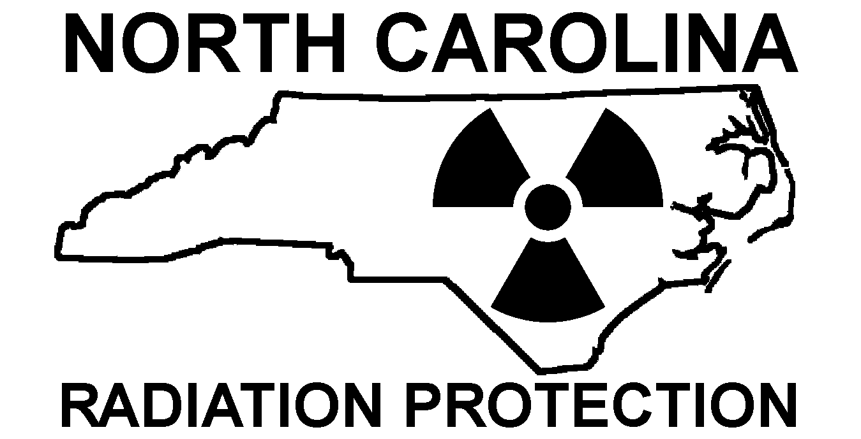 | radiographic and reciprocity location report
INSTRUCTIONS FOR USE: Read these instructions carefully. These instructions are presented to assist reciprocal licensees and industrial radiography licensees in completing the attached location report. Once the report is properly filled out, please email to: Reciprocity Coordinator @ Reciprocity.ram@dhhs.nc.gov
The completed forms may also be mailed to: Reciprocity Coordinator, Radioactive Materials Branch, 1645 Mail Service Center, Raleigh, NC 27699-1645
This Guide is not intended to, and does not, create any rights or privileges, substantive or procedural, which are enforceable by person. The publication of this guide, or any version thereof, does not place any limitation of the otherwise lawful prerogatives or discretion of the Department of Environment and Natural Resources, Division of Environmental Health, Radiation Protection Section.
For RECIPROCAL LICENSEES
If you have not previously submitted training verification for any individual listed in this section, you MUST do so when transmitting the report. Personnel should have identification and training documentation with them at the jobsites within North Carolina.
For N.C. LICENSEES
Be sure that all individuals listed in the location report are authorized under your current license. Personnel should have identification and training documentation with them at the jobsites within North Carolina.

The Radioactive Materials Branch (Branch) published this guidance to assist licensees in completing the location report contained herein. North Carolina licensees who engage in industrial radiography and ALL Reciprocal Licensees MUST complete this form.

You are strongly encouraged to TYPE the information into the form. This form is posted to the Branch’s website (www.ncradiation.net/rms/rms.htm) and is available in two formats (Microsoft Word and Adobe PDF). You may download the form and save it to your local computer.

Please note that if the information contained in the transmitted report is illegible, the report may be deemed “incomplete” and the licensee may be subject to compliance and escalated enforcement action(s).

EXPLANATION OF THE REPORT

The attached location report is divided into four (4) sections. Comments on certain portions of the form are noted below.

Section 1: Licensee Information
Please be sure that the contact person listed in this section is KNOWLEDGEABLE of the activities being conducted at the work location. This individual is normally the Radiation Safety Officer, but can be anyone in your organization.

Section 2: Personnel / Equipment / Sources Information

1. The individuals listed should be authorized by your license to work with the radioactive materials listed.

2. Please provide a cellular phone or pager number (if available) for at least one individual listed as an equipment operator.

3. List each isotope on a separate line. Be sure to check the appropriate box for activity units.

Section 3: Location of Work
1. Please describe the location IN DETAIL if the exact physical address of work is not applicable. An example of a good description is:
“2 miles north of intersection of Hwy XXX and Hwy YYY on State Road 9999, near Anytown, NC, 29999-9999”

2. The contact person for this section must be an individual at the COMPANY FOR WHOM THE WORK IS BEING CONDUCTED. Please verify the phone number prior to filing the report. Again, this person must be knowledgeable of the location and nature of the job.

3. Please list the beginning and ending dates and times for the particular work location. If you are to be at a location for more than one day, you may list a range of dates (e.g. 03/01/2004 – 03/25/2004).

4. Please indicate whether or not this is a REVISION to a PREVIOUSLY SUBMITTED location report.

5. The N.C. Regulations allow for relief from the three-day notification requirement if “…the three day period would impose undue hardship…” The agency always reserves the right to deny work at a location if we determine that “…the action [that is, the agency denial] is necessary in order to prevent undue hazard to public health and safety or property.” In order for the agency to grant relief from the three day notification requirement, the applicant MUST provide a reason that the notification is being made less than 3 days before the scheduled work. Failure to give a reason may result in denial of the authorization.

6. The agency now requires notification of work on or near State Ports, Airports or work within the coastal waters.

For the State Ports and Airports, give the name (i.e., RDU International, State Port at Wilmington, etc.).

“Coastal Waters”, as defined in the N.C. General Statutes, means operating within 3 nautical miles of the shoreline (about 3½ statute miles). The proper way to note this on the form is to state “2 miles SSE of Morehead City, NC”

Section 4: Type of Work to be Performed:
Please check the appropriate type of work. If “other”, please specify the type of work in the space provided.

Please note that “Medical” means “…the intentional exposure to individuals for medical purposes.” This DOES NOT apply to companies performing source change-outs or equipment repair/service on medical devices.

Please review the form carefully before transmitting

as a reminder, you must notify the agency if any information in the report changes

 |  |  |  |  |  | RADIATION PROTECTION SECTION  RADIOACTIVE MATERIALS BRANCH  radiographic and reciprocity location report |  |  |  |  |  |  |  |  |  |  |  |  |  |  |  |  |  |  |  |  |  |  |  |  | (RMB USE ONLY)
 |  |  |  |  |  |  |  |  |  |  |  |  |  |  |  |  |  |  |  |  |  |  |  |  |  |  |  |  |  |  | DT
 |  |  |  |  |  |  |  |  |  |  |  |  |  |  |  |  |  |  |  |  |  |  |  |  |  |  |  |  |  |  | HP
 |  |  |  |  |  |  |  |  |  |  |  |  |  |  |  |  |  |  |  |  |  |  |  |  |  |  |  |  |  |  | A/D
INSTRUCTIONS: **PLEASE TYPE OR PRINT** Complete all applicable sections of this form as described in the instructions above. Completed forms MUST be received 72 hours prior to the initiation of work at the location listed below. Completed forms may be Reciprocity.ram@dhhs.nc.gov or mailed to: Radioactive Materials Branch, 1645 Mail Service Center, Raleigh, N.C., 27699-1645.
LICENSEE INFORMATION |  |  |  |  |  |  |  |  |  |  |  |  |  |  |  |  |  |  | WORK LOCATION INFORMATION
Date of Notification |  |  |  |  |  |  |  |  |  |  |  | Time (military) |  |  |  |  |  |  | Company
 |  |  |  |  |  |  |  |  |  |  |  |  |  |  |  |  |  |  | EXACT physical address or DESCRIPTION of work location
Licensee:
Radioactive Materials License No.
Reciprocal License No. (if applicable) |  |  |  |  |  |  |  |  |  |  |  |  |  |  |  |  |  |  | Individual from the company listed above who can be contacted about this notification |  |  |  |  |  | Name
Employee to be contacted about this notification |  |  |  | Name |  |  |  |  |  |  |  |  |  |  |  |  |  |  |  |  |  |  |  |  | Tel No.
 |  |  |  | Tel No. |  |  |  |  |  |  |  |  | Fax No. |  |  |  |  |  |  |  |  |  |  |  | Fax No.
 |  |  |  | e-mail |  |  |  |  |  |  |  |  |  |  |  |  |  |  |  |  |  |  |  |  | e-mail
PERSONNEL/EQUIPMENT/SOURCES |  |  |  |  |  |  |  |  |  |  |  |  |  |  |  |  |  |  | Date(s) and Time(s) of Work |  |  | Beginning Date |  |  |  |  |  |  |  | Is this a revision to a previous notification?  YES NO
Personnel / Authorized Users |  |  |  |  |  |  |  |  |  |  |  |  |  |  |  |  |  |  |  |  |  | Ending Date
Name |  |  |  |  |  |  |  | Cellular / Pager No. |  |  |  |  |  | If additional individuals need to be listed here, supply the names as an attachment to the report. |  |  |  |  |  |  |  | Shift Start Time
 |  |  |  |  |  |  |  |  |  |  |  |  |  |  |  |  |  |  |  |  |  | Shift End Time
 |  |  |  |  |  |  |  |  |  |  |  |  |  |  |  |  |  |  | Reason for late notification (LESS THAN 3 days PRIOR TO WORK):
Equipment
Make |  |  |  |  |  |  | Model |  |  |  |  |  |  |  | Serial No. |  |  |  | Is the work location on or near any of the following:
 |  |  |  |  |  |  |  |  |  |  |  |  |  |  |  |  |  |  |  |  | If “YES” give name of port pr airport or location in miles from shore
 |  |  |  |  |  |  |  |  |  |  |  |  |  |  |  |  |  |  | State Port |  |  |  | YES NO
 |  |  |  |  |  |  |  |  |  |  |  |  |  |  |  |  |  |  | Airport |  |  |  | YES NO
Isotopes [use chemical abbreviations (e.g. Ir-192)] |  |  |  |  |  |  |  |  |  |  |  |  |  |  |  |  |  |  | NC Coastal Waters¹ |  |  |  | YES NO
Isotope |  |  |  |  |  |  | Activity |  |  |  |  |  |  |  | Specify Units |  |  |  | 1 | Coastal Waters are defined as 3 nautical miles (approximately 3½ statute miles) from the low water mark.
 |  |  |  |  |  |  |  |  |  |  |  |  |  |  | Ci mCi |  |  |  | 1
 |  |  |  |  |  |  |  |  |  |  |  |  |  |  | Ci mCi |  |  |  | If ANY information in this form changes, notify the agency
 |  |  |  |  |  |  |  |  |  |  |  |  |  |  | Ci mCi |  |  |  | Telephone: 919-814-2250 |  |  |  |  |  |  |  | Email: Reciprocity.ram@dhhs.nc.gov
type of work to be performed
 | Pipeline |  |  |  | Equipment or Source Install |  |  |  |  |  |  |  |  |  |  | Tank |  |  |  |  | Other (explain)
 | Fabrication |  |  |  | Concrete / Foundation |  |  |  |  |  |  |  |  |  |  | Landfill |  |  |  |  | Road Construction
 | Medical* |  |  |  | Service and/or Repair |  |  |  |  |  |  |  |  |  |  | Lead paint analysis
* “Medical” means the intentional exposure to individuals for medical purposes

